

BE635

User Manual

(V_1.0)

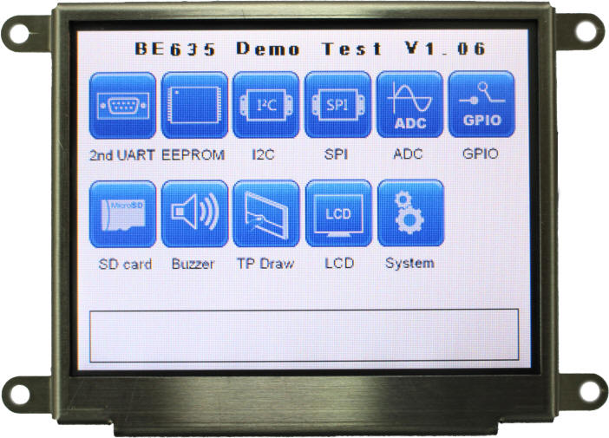

**© 2013-2014 Bolymin, Inc. All Rights Reserved.**

**Copyright**

Copyright © 2013-2014 BOLYMIN, INC. All rights reserved. No part of the materials may be reproduced, copied or translated into any form by any means without prior written consent from BOLYMIN, INC.

**Disclaimer**

The contents of this document are subject to change without notice. Bolymin, Inc. reserves the right to make changes without further notice to any product herein to improve reliability, function or design. Bolymin, Inc. does not assume any liability arising out of the application or use of any product or circuit described herein; neither does it convey any license under its patent rights, nor the rights of others. Customers are advised to consult with Bolymin, Inc. or its commercial distributors before ordering.

Getting Support

**Contact Information**

|  |  |
| --- | --- |
| **Company** | BOLYMIN, INC |
| **Address** | 5F, 38 Keya Road, Daya Dist., Central Taiwan Science Park, 42881 Taichung City, Taiwan, R.O.C. |
| **TEL** | +886-4-2565-8689 |
| **FAX** | +886-4-2565-8698 |
| **Web Site** | [http://www.bolymin.com.tw](http://www.bolymin.com.tw/) |
| **Email** | [info@bolymin.com.tw](mailto:info@bolymin.com.tw) |
| **Service Hour** | 09:00 – 18:00 (UTC/GMT + 8) , Mon. to Fri. |



Revision History

|  |  |  |
| --- | --- | --- |
| **Version** | **Note** | **Date** |
| 1.0 | Original Version | 2014/03/17 |
|  |  |  |
|  |  |  |
|  |  |  |
|  |  |  |
|  |  |  |
|  |  |  |
|  |  |  |
|  |  |  |
|  |  |  |
|  |  |  |
|  |  |  |
|  |  |  |
|  |  |  |
|  |  |  |
|  |  |  |
|  |  |  |
|  |  |  |
|  |  |  |
|  |  |  |
|  |  |  |

Table of Content

Chapter 1 Introduction 6

1.1 Features 6

1.2 Board Layout 6

1.4 Mechanical Dimension 7

1.5 Board Specification 8

1.6 Ordering Information 9

1.7 Package Content 10

Chapter 2 Installation 12

2.1 Connectors 12

CN1: ISP Pin Definitions 13

CN2: System Reset Pin Definitions 13

CN7: Power Pin Definitions (micro FIT 3.0) 14

CN8: One RS232 / One RS422 Pin Definitions 16

CN8: One RS232/One RS485 Pin Definitions 17

CN9: SPI & IIC Pin Definitions 18

CN10: GPIO / ADC Pin Definitions 19

CN11: Mini USB Pin Definitions 19

2.2 How to install USB driver 20

Chapter 3 Software Development Tool & Utility 25

3.1 How to program the demo code 26

3.2 Connecting the device 30

3.3 How to operate the demo program 32

Running Hyper Terminal 32

2nd UART Test 36

I2C Test 39

SPI Test 40

ADC Test 41

Buzzer Test 47

Touch panel Draw Test 48

LCD Test 49

System Setting 50

To update the Table of Contents, place the cursor on the first item and press F9.

# Chapter 1 Introduction

Welcome to use BE635 which is designed for an embedded control board with 3.5” TFT LCD display for customer to control other peripherals or devices. This chapter is to offer you basic information regarding BE635 to help you incorporate BE635 into your system.

## 1.1 Features

BE635 is designed based on PIC32 32-bit microprocessor, which requires no operating system to run on. Together with a 320x240 3.5” TFT LCD and LED backlight built-in, this all-in-one LCD embedded system BE635 helps designer to enhance a compact design with cost, space, and design phase saving.

Armed with RS232, RS422, RS485, USB, SPI, and I2C interface ports, BE635 is capable of interfacing and communicating with many devices and peripherals .The BE635 is therefore suitable for any industrial control panel for factory automation equipment, electronic instrument, HMI (human-machine interface), office automation equipment, medical equipment, parking system, ticketing system and so on. 512KB in-system self-programmable Flash offers sufficient ROM size for designers to develop their applications.

BE635 is more than simply a Microchip development board: it integrates display and I/O so that developers may start her application without the hassle of hardware integration. Henceforth, a quick time to market for customers’ innovative product is ensured.

## 1.2 Board Layout

This layout shows the location of each important IC, connector and jumper. Please refer to chapter 2 for further information on jumpers and connectors.

**1.3 Block Diagram**



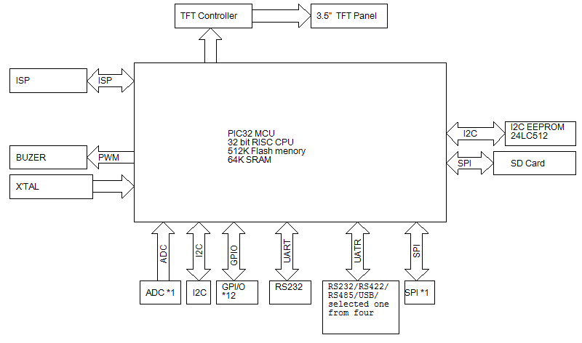

## 1.4 Mechanical Dimension

(Front and side view)



TBD

(Bottom view)



## 1.5 Board Specification

|  |  |
| --- | --- |
| **MCU** | High-performance, low-power PIC® 32-bit microprocessor  Microchip PIC32 MCU |
| **Memory** | 512K Bytes In-System Self-Programmable Flash  64K Bytes Internal SRAM  16K Bytes EEPROM |
| **Display** | 3.5” TFT LCD with 320x240 resolution  with LED backlight |
| **Touch Panel** | Supports four-wired resistive touch panel |
| **Serial Ports** | Supports 1 x RS232 port, and 1 x RS232/RS422/RS485/USB shared port |
| **Power** | DC 5.0V |

## 1.6 Ordering Information

|  |  |  |  |  |  |  |  |
| --- | --- | --- | --- | --- | --- | --- | --- |
| **Part No. (P/N)** | **Resolution** | **Voltage** | **RS-232** | **RS-232** | **RS-422** | **RS-485** | **USB (UART)** |
| **BE635BM1A1N** | 320 * 240 | 5V |  |  |  |  |  |
| **BE635BM1A2N** | 320 * 240 | 5V |  |  |  |  |  |
| **BE635BM1A3N** | 320 * 240 | 5V |  |  |  |  |  |
| **BE635BM1A4N** | 320 * 240 | 5V |  |  |  |  |  |

**Note1.** If you select USB interface version, you need to install the USB to RS232 driver. Please refer the **section 2.2** to know how to install the driver.

## 1.7 Package Content

Please check your package content upon receiving the product parcels. Besides the BE635 unit, make sure the following accessories (User selection) are included as well.

|  |
| --- |
| **NOTE**: The term as "**S/N Number**" is the serial number of all accessories provided by Bolymin. |

|  |  |  |
| --- | --- | --- |
| **S/N: OPBE657AM1E00** | **S/N: OPBE657AM1F00** | **S/N: OPBE657AM1G00** |
| SPI CABLE | UART CABLE | GPIO CABLE |
| Cable 1: SPI, I2C (20cm) | Cable 2: UART (50cm) | Cable 3: GPIO, ADC (50cm) |

|  |  |  |
| --- | --- | --- |
| **S/N: OPBE657AM1010** | **S/N: OPBE657AM1020** | **S/N: OPBE657AM1030** |
| 4G | **8G** | 16G |
| Micro SD 4GB | Micro SD 8GB | Micro SD 16GB |

|  |  |  |
| --- | --- | --- |
| **S/N: OPBE657AM1040** | **S/N: OPBE657AM100A** | **S/N: OPBE657AM100B** |
| 32G | 圖片 6 | 圖片 66 |
| Micro SD 32GB | Microchip PICKIT 3  + Program line | Program line |

**Note1.** The Cable 1~3 is used for developed.

**Note2.** The Micro SD 4GB is standard accessory.

**1.8 Absolute Maximum Ratings**

|  |  |  |  |  |  |
| --- | --- | --- | --- | --- | --- |
| **Item** | **Symbol** | **Min** | **Typ.** | **Max** | **Unit** |
| Operating Temperature | TOP | -20 | － | +70 | ℃ |
| Storage Temperature | TST | -30 | － | +80 | ℃ |
| Supply Voltage For LCD | Vdd-Vss | － | － | 6.0 | V |

# Chapter 2 Installation

This chapter covers fundamental information of BE635 connectors, in order to help designers to configure correct settings and connections between BE635 and the respective application.

## 2.1 Connectors

Connectors are the key link between BE635 and external devices. Detailed locations and functions of available connectors are tabled and illustrated below.

1



2

3

4

5

8

7

6

|  |  |  |
| --- | --- | --- |
| **Label** | **Pin No.** | **Function** |
| 1**:CN1** | 5 | In-System Programming (ISP) |
| 2**:CN2** | 2 | System Reset |
| 3**:CN5** | 5 | Mini USB Connector |
| 4**:CN6** | 9 | Micro SD |
| 5**:CN7** | 2 | DC Power Jack |
| 6**:CN9** | 8 | SPI / I2C |
| 7**:CN8** | 8 | Series Interface Input |
| 8**:CN10** | 15 | GPIO / ADC Input |

### CN1: ISP Pin Definitions

|  |  |  |
| --- | --- | --- |
| **Pin No.** | **Signal** | **Description** |
| 1 | /MCLR, VPP | Power |
| 2 | VDD_TGT | Power on Target |
| 3 | GND | Ground |
| 4 | PGD | Connects to PIC32 port PGD1, ICSPDAT |
| 5 | PGC | Connects to PIC32 port PGC1, ICSPCLK |

We recommend using the Microchip PICKit 3 for ISP. Here is the connector definition about ISP. Please refer to the section 1.4 of the programming guide for detailed software operation.

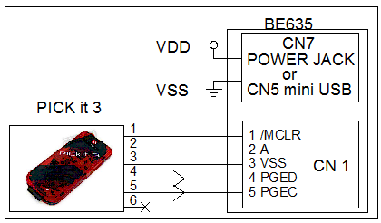

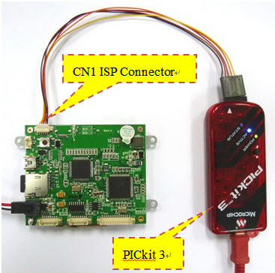

### CN2: System Reset Pin Definitions

|  |  |  |  |
| --- | --- | --- | --- |
| **Pin No** | **Signal** | **Pin No.** | **Signal** |
| **1** | System Reset | **2** | VSS |

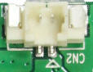

PIN1

### CN7: Power Pin Definitions (micro FIT 3.0)

PIN1

PIN2

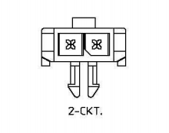

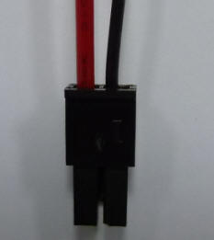

|  |  |  |  |
| --- | --- | --- | --- |
| **Signal** | **Type** | **Pin No.** | **Description** |
| VSS | P | 1 | Logic Power Supply (ground) |
| VDD | P | 2 | Logic Power Supply DC 5.0V, |

Mates with micro FIT (3.0) receptacle 43645-0200**CN8: Dual RS232 Pin Definitions**

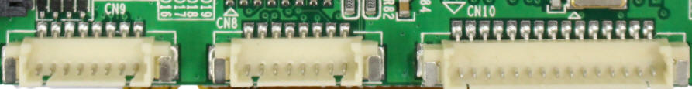

|  |  |  |  |
| --- | --- | --- | --- |
| **Pin No** | **Signal** | **Pin No.** | **Signal** |
| **1** | VSS | **5** | NC |
| **2** | RS232 RX_1 | **6** | RS232 RX_2 |
| **3** | RS232 TX_1 | **7** | RS232 TX_2 |
| **4** | VSS | **8** | NC |

UART1 of BE635 offers one RS232 port (the voltage level is +/- 12V) for connection with a PC or other RS232 devices.

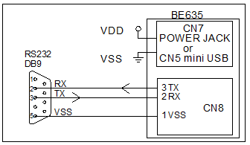 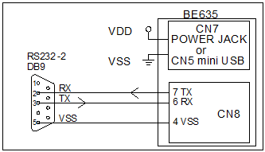

RS232-1 RS232-2

Pin Definition of DB9 Connector:

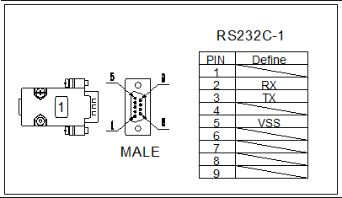 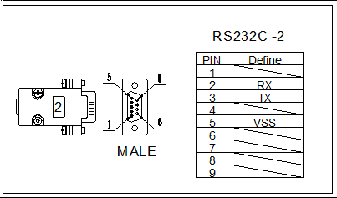

6

1

5

9

5

6

9

1

### CN8: One RS232 / One RS422 Pin Definitions

|  |  |  |  |
| --- | --- | --- | --- |
| **Pin No** | **Signal** | **Pin No.** | **Signal** |
| **1** | VSS | **5** | RS422 T+ |
| **2** | RS23 RX | **6** | RS422 T- |
| **3** | RS232 TX | **7** | RS422 R- |
| **4** | VSS | **8** | RS422 R+ |

 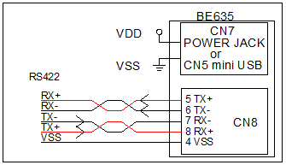

RS232 RS422

Pin Definition of DB9 Connector:

 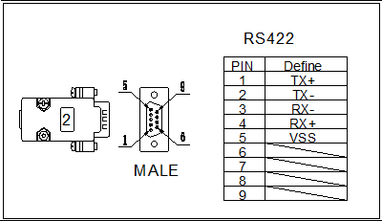

1

5

6

9

1

5

6

9

### CN8: One RS232 / One RS485 Pin Definitions

|  |  |  |  |
| --- | --- | --- | --- |
| **Pin No** | **Signal** | **Pin No.** | **Signal** |
| **1** | VSS | **5** | RS485 T+ |
| **2** | RS232 RX | **6** | RS485 T- |
| **3** | RS232 TX | **7** | NC |
| **4** | VSS | **8** | NC |

 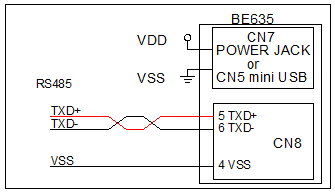

RS232 RS485

Pin Definition of DB9 Connector:

 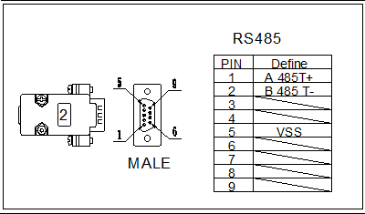

1

5

6

9

1

5

6

9

### CN9: SPI & IIC Pin Definitions



|  |  |  |  |
| --- | --- | --- | --- |
| **Pin No** | **Signal** | **Pin No.** | **Signal** |
| **1** | SDO | **5** | VSS |
| **2** | SS | **6** | SDA |
| **3** | SDI | **7** | SCL |
| **4** | CLK | **8** | VSS |

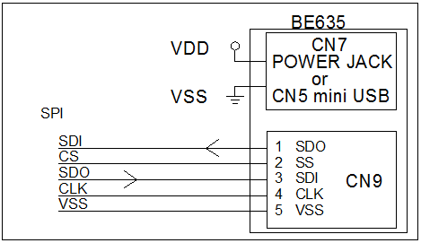 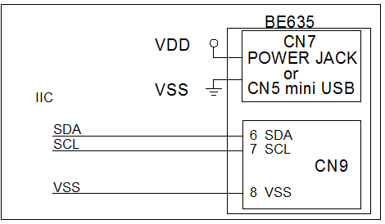

SPI IIC

### CN10: GPIO / ADC Pin Definitions



|  |  |  |  |
| --- | --- | --- | --- |
| **Pin No** | **Signal** | **Pin No.** | **Signal** |
| **1** | GPIO1 | **9** | GPIO9 |
| **2** | GPIO2 | **10** | GPIO10 |
| **3** | GPIO3 | **11** | GPIO11 |
| **4** | GPIO4 | **12** | GPIO12 |
| **5** | GPIO5 | **13** | VSS |
| **6** | GPIO6 | **14** | ADC IN |
| **7** | GPIO7 | **15** | ADC VSS |
| **8** | GPIO8 |  |  |

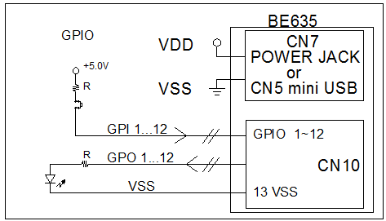 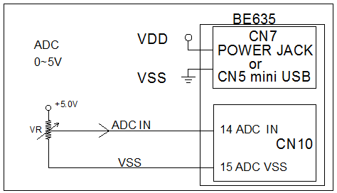

GPIO: ( I/O Voltage 5.0V / 25mA max) ADC: (Voltage Range = 0~5V)

### CN11: Mini USB Pin Definitions

|  |  |  |  |
| --- | --- | --- | --- |
| **Pin No** | **Signal** | **Pin No.** | **Signal** |
| **1** | VUSB | **4** | NC |
| **2** | D- | **5** | VSS |
| **3** | D+ |  |  |

## 2.2 How to install USB driver

The BE635 provides a stand-alone USB to RS232 serial converter (optional). If you select this interface, all what you need to do is to install the USB driver (please download USB driver from URL: <http://www.bolymin.com.tw/dl/BE6XX_USB_driver.rar> ) to your Windows System by referring to below instructions. Take Windows 7 for example, to install the USB driver on Windows 7 for the first time.

**Step 1:** Connect BE635 device to your computer's USB port and power on the BE635.

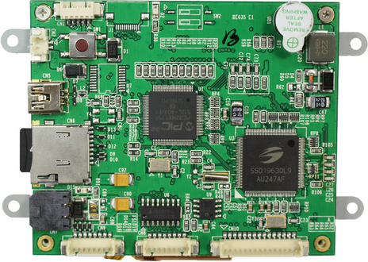

Power Jack

(DC 5V)

Mini USB connector,

connect to PC

**Step 2:** Right-click on **Computer** from your desktop or Windows Explorer, and select **Device Manager**. Locate and expand **Other device**, you can see the MCP2200 USB Serial Port Emulator.

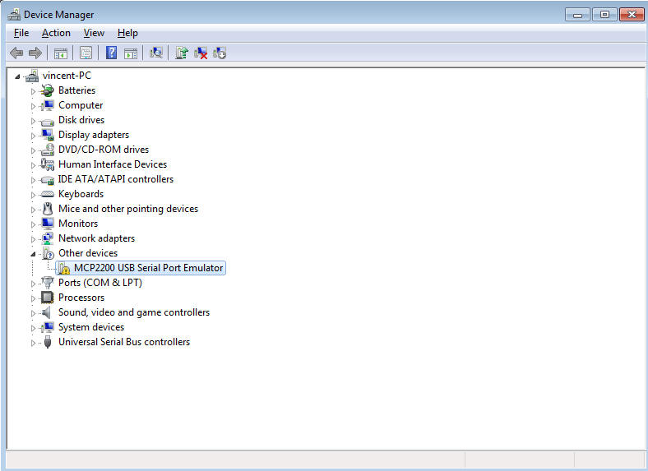

**Step 3:** Right-click the device name (such as **MCP220 USB Serial port Emulator**) and select Update Driver Software. This will launch the Hardware Update Wizard.

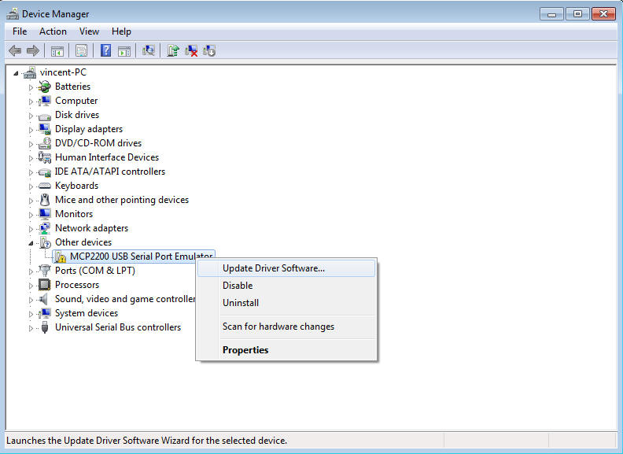

**Step 4:** Select “Browse my computer for driver software”.

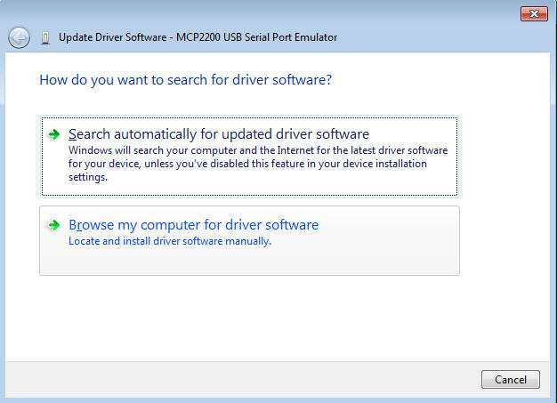

**Step 5:** Click Browse and locate the USB driver folder (X64 for windows 64 bit system, x86 for windows 32 bit system) and click “OK” to next.

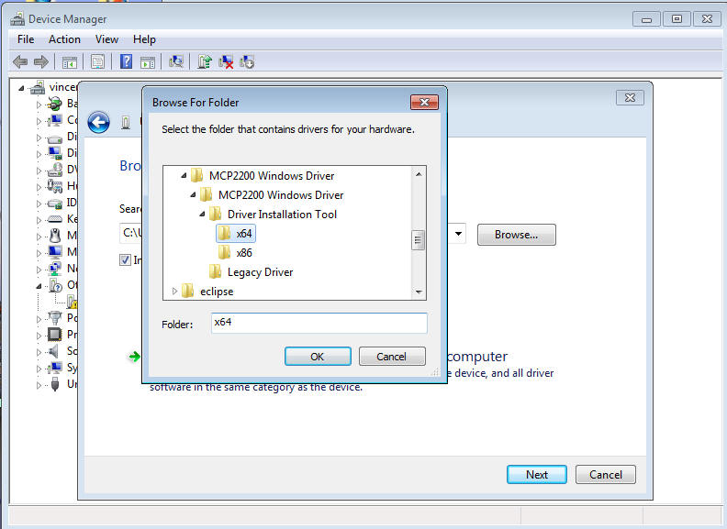

**Step 6:** Click **Install** to install the driver.

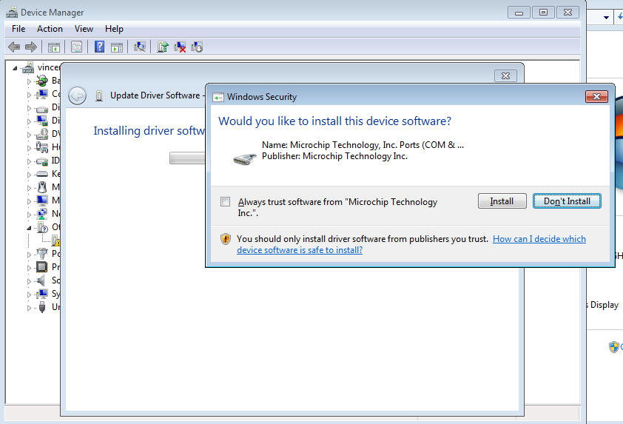

**Step 7:** Installing driver software.

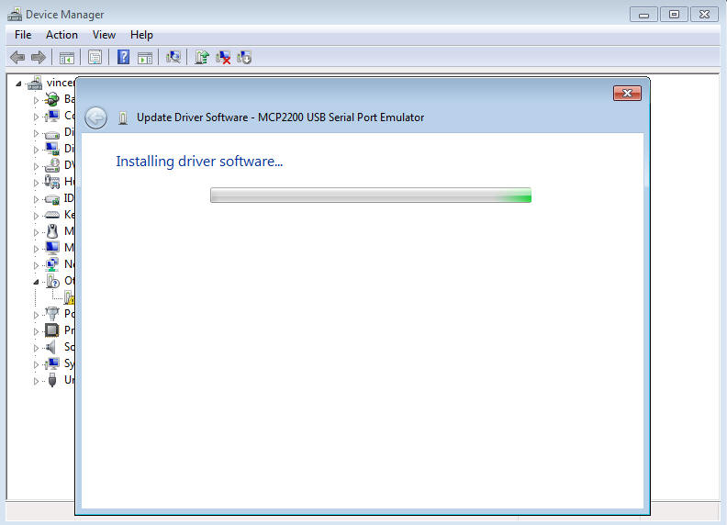

**Step 8:** Now the USB driver installation for BE635 is completed.

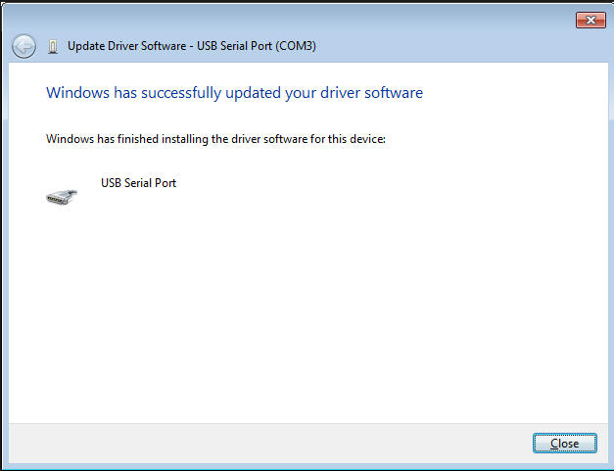

**Step 9:** You can see the **USB Serial Port** at **Ports (COM & LPT)** of device Manager. The following example shows **COM3** is available.

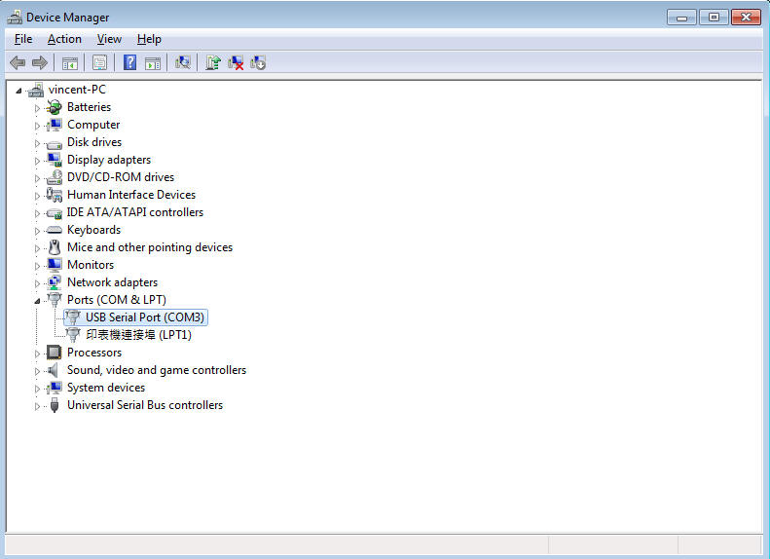

# Chapter 3 Software Development Tool & Utility

This chapter will show you how to setup and how to use the hyper terminal to operate the demo program on BE635. Following table lists the recommended software development tool and hardware connection of BE635.

|  |  |
| --- | --- |
| **Item** | **Description** |
| Software Development Tool | MPLAB Version 8.85 |
| Programmer | PICkit3 |
| Hardware Connection | Snap1 |

## 3.1 How to program the demo code

**Step 1:** Connect PICkit 3 programmer to the connector **CN1** and provide the power to BE635,

which is indicated in below image.

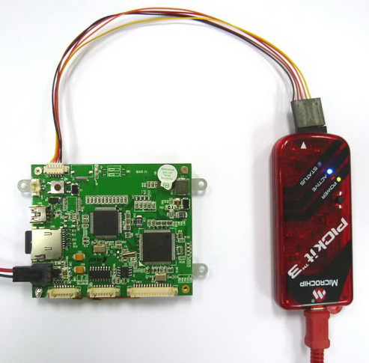

Power Jack

CN1 ISP Connector

Connect to PC

PICkit 3

**Step 2:** Start MPLAB IDE by clicking either on the Desktop or Start menu item, how to install the MPLAB IDE, please refer to the BE635 programming guide section **1.2 Software Development Tool Installation.**



**Step 3:** Inside MPLAB IDE, click in the menu bar on **File 🡪 Import** and load the hex file into MPLAB IDE.

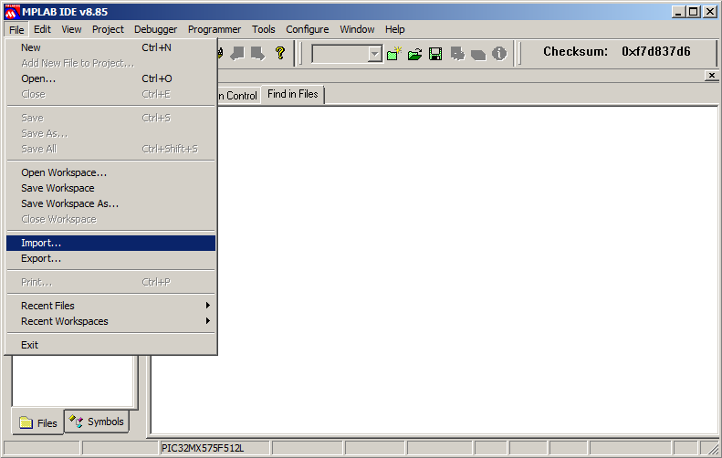

**Step 4:** Import Hex file.

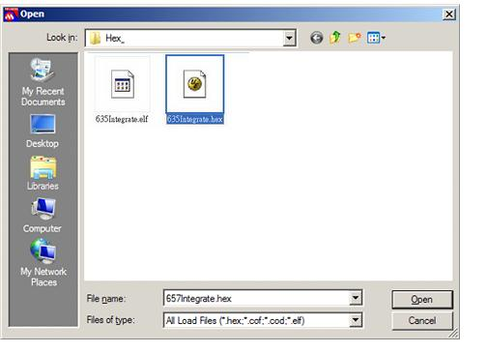

**Step 5:** **Select Programmer:** Inside MPLAB IDE, please select the correct programmer according to your configuration. In the menu bar, please click on **Programmer 🡺 Select Programmer 🡺 PICkit3**.

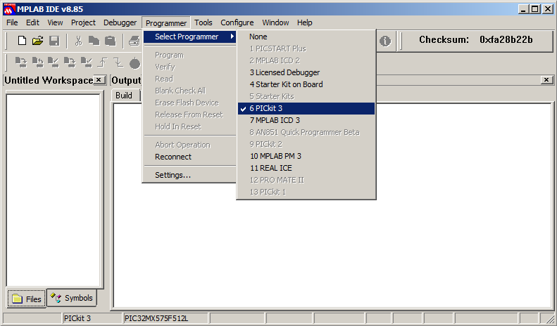

**Step 6:** Power target circuit from PICkit3, check **Programmer 🡺 Setting 🡺 Power** and place a checkmark at “Power target from PICkit3”.

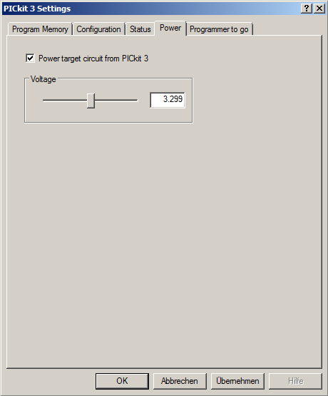

**Step 7:** The programmer is connected to MPLAB IDE successfully, when it shows the Device ID Revision in MPLAB IDE.

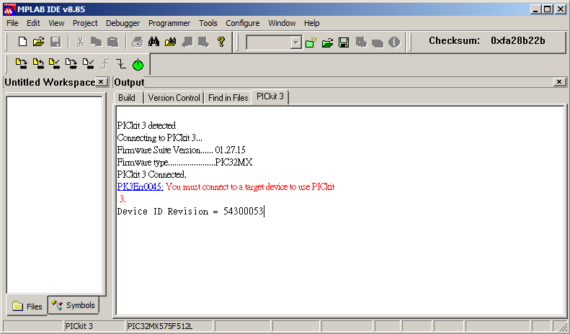

**Step 8:** To upload the hex file to your target, please click “Program” icon to upload the hex file to BE635.

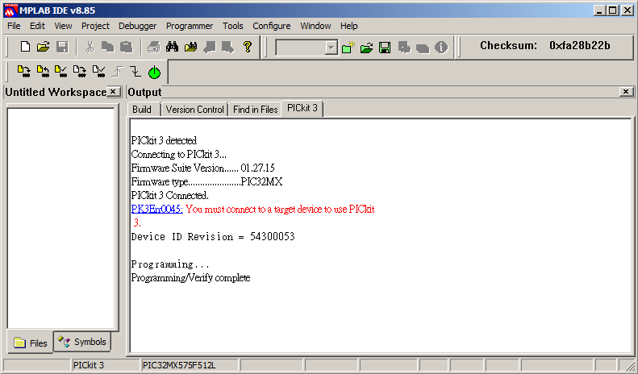

Click on “Program”

## 3.2 Connecting the device

Below image illustrates how to connect BE635.

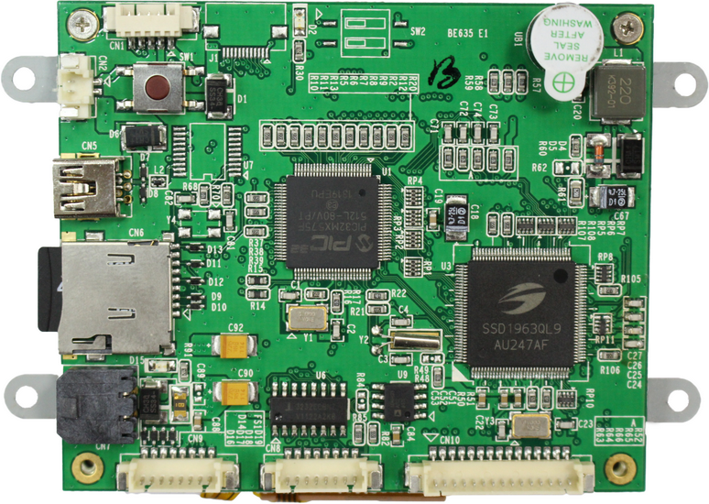

Micro SD Card slot

Power connector

I2C and SPI connector

GPIO connector

Serial Port

UART 1 , 2

**Step 1:** Connect the test board connectors (GPIO, Serial port, I2C & SPI connector ) if you want to test or use these functions.

**Step 2:** Connect the test board with the cable configuration as shown below. Connect the test board to +5V DC

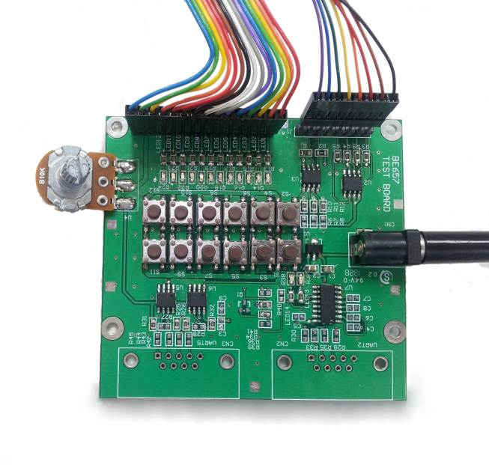

I2C/SPI cable

+5V DC Power supply

GPIO cable

Test board

**Step 3:** To control the device in terminal mode or send / receive data using the 2nd UART, please connect the Serial Port (UART1, UART2) cable. The serial cable with 3 wires controls the device using a terminal emulator such as HyperTerminal. In order to send and receive data via the RS232/RS422/RS485/USB, connect UART2 according to below image (cable with 5 wires).

**3 wires** 🡪 UART 1 HyperTerminal connection

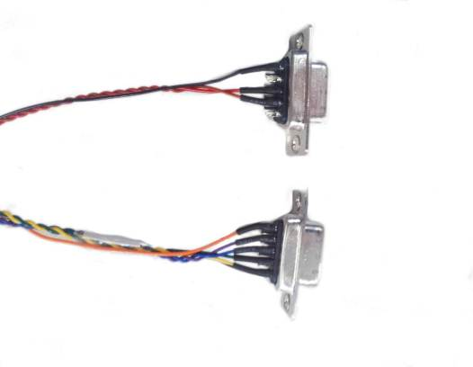

**5 wires** 🡪 UART 2

Auxiliary connection

**Step 4:** Next, decompress files (**BE635_DTP_XXXXXXXX_vXXX.rar** ) that Bolymin provides and copies the content of demo_pic folder to the micro SD card’s main folder and insert the card into BE635.

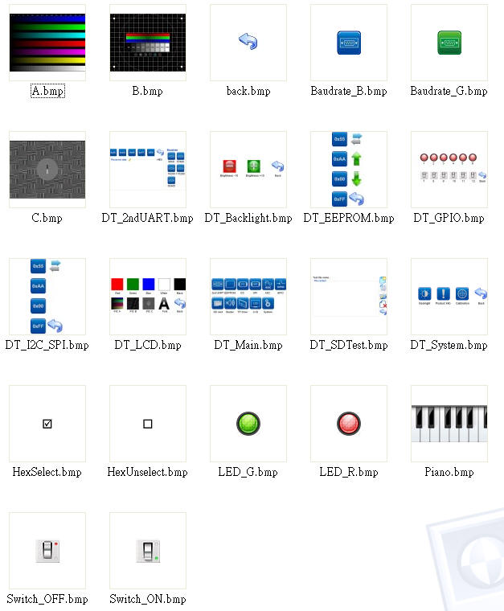

Demo picture

## 3.3 How to operate the demo program

BE635 supports touch panel. Bolymin will calibrate the touch panel before shipping out. User can click the screen of BE635 to operate the demo program, if touch panel couldn’t work, you can use hyper terminal for terminal emulation and recalibration. The PC keyboard can emulate as an input device to BE635. Here is the step-by-step guide.

### Running Hyper Terminal

**Step 1:** Make sure you have at least one **RS-232 serial port** available. The following example shows **COM3** is available.

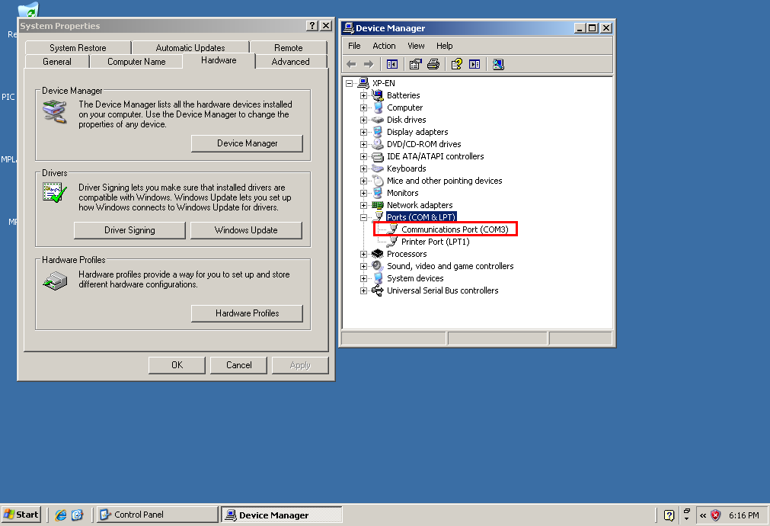

**Step 2:** On Windows XP PC: **Start** 🡺 **All programs** 🡺 **Accessories** 🡺 **Communication 🡺 HyperTerminal** (or Windows key +R, enter “ hypertrm ”)

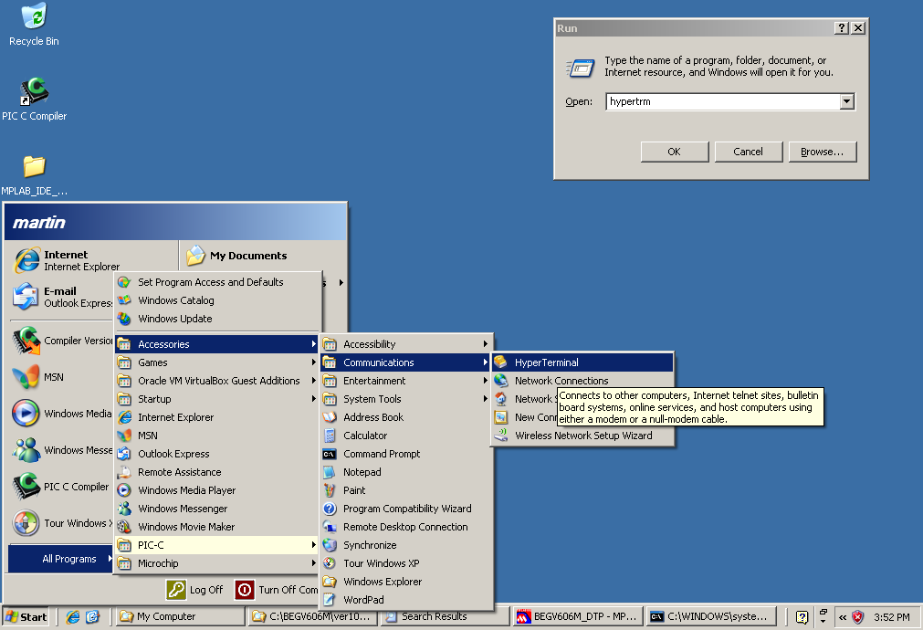

**Step 3:** Click **No** if you do not use hyper terminal to telnet to default host.

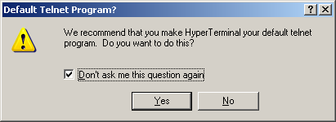

**Step 4:** Enter the file name to store the hyper terminal settings. System will auto add a .**ht**

extension name.

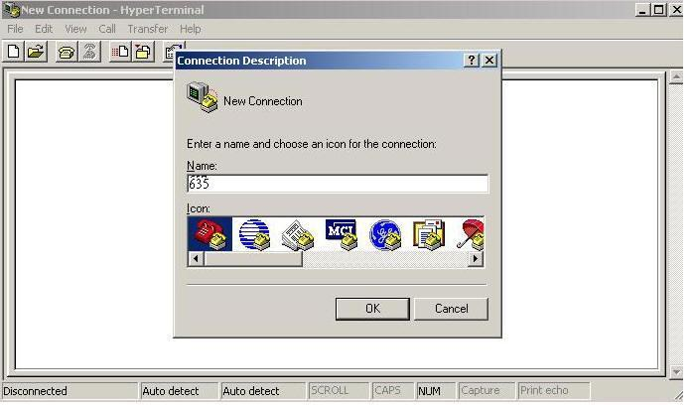

Please define a name and choose a icon for this connection, and click **Ok** to continue.

**Step 5:** Select **COM** port as appropriate. Hyper terminal will pull down only valid COM ports.

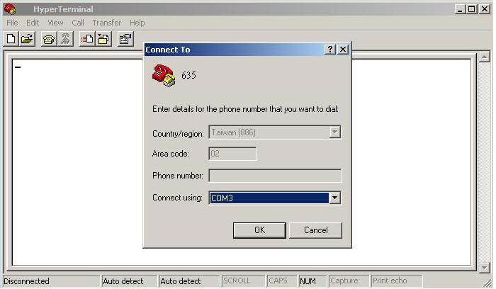

Choose a suitable COM port, and click **Ok** to continue.

**Step 6:** It is required to set the serial communication as follows – **115200 bps, / 8/ None/ 1/ None**

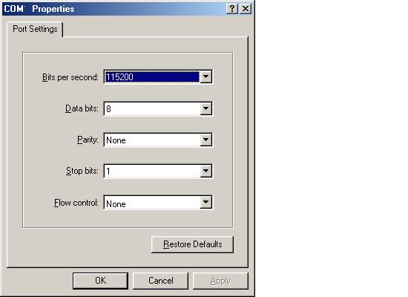

Key in COM port setting:

115200/ 8/ No/ 1/ No, and click **ok** to continue.

**Step 7:** Now you plug in the power connector into the unit. The main screen on the device lets you choose the operations. Available operations are showed in Hyper Terminal Screen as depicted below. On your keyboard, hit the respective number to execute the operation.

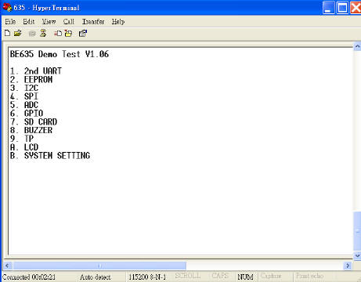 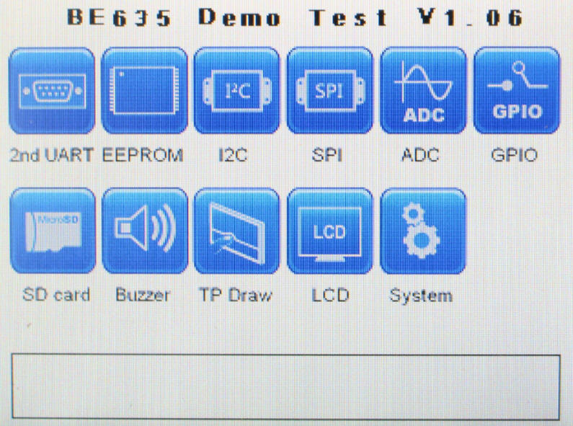

(Hyper Terminal Screen) (BE635 Screen)

|  |  |
| --- | --- |
| **Name** | **Description** |
| **2nd UART** | Test of 2nd UART sending/receiving functionality at different baud rates |
| **EEPROM** | Test of EEPROM reading/writing functionality |
| **I2C** | I2C EEPROM; test of EEPROM reading/writing functionality |
| **SPI** | SPI FLASH; test of FLASH reading/writing functionality |
| **ADC** | Oscilloscope display of ADC values versus time |
| **GPIO** | General purpose I/O testing. Setting output pins, reading input pins |
| **SD Card** | Create File/Read/Write/Delete functionality testing |
| **Buzzer** | Application example: Piano |
| **TP Draw** | Application example: Touchpad drawing program |
| **LCD** | Screen filling examples, displaying images examples |
| **System** | Backlight Intensity setting, product information, T/P calibration |

### 2nd UART Test

This screen lets you test the 2nd UART functionality

Return to main screen

Sending Bytes 0x55, 0xAA, 0x00, 0xFF and letters & symbols

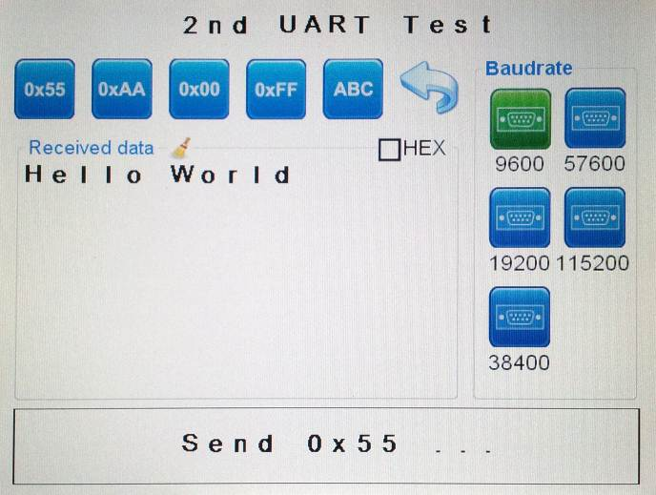

Baud rate settings

Switch from ASCII to hexadecimal display

**Step 1:** First, connect the 2nd UART to your PC in the same way as you connected the 1st UART as described in **section 3.2 connecting the device**.

**Step 2:** Set a baud rate in HyperTerminal. On BE635, set the same baud rate in the GUI. Available baud rates are **9600, 19200, 38400, 57600, 115200 .**

**Step 3:** On BE635, tap on one of the send buttons (0x55, 0xAA, 0x 00, 0xFF, ABC) to send the characters to the 2nd UART’s Hyper Terminal. For example that to send the characters with internal fonts from 1st UART, the Hyper Terminal of 2nd UART will show the characters with internal fonts.

2nd UART

1st UART

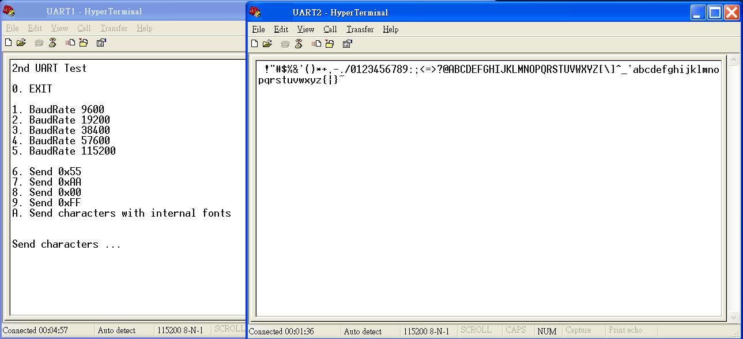

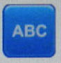

**Step 4:** Type in the 2nd UART’s HyperTerminal **“Hello World”.** The sent string now shows in the receive area on the device.

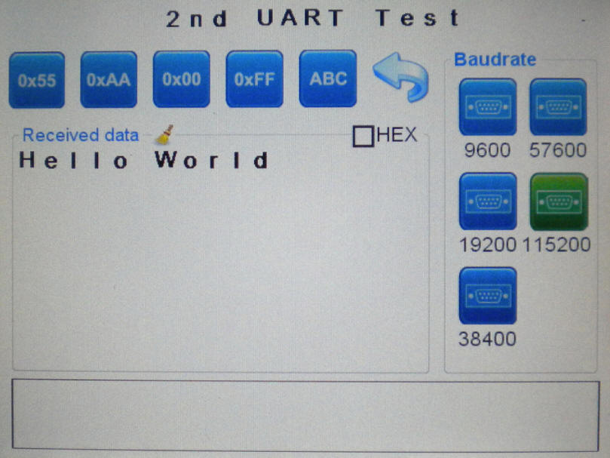

**Step 5:** Once the receive area is full, you can delete the contents with the broom 

**Step 6:** In Terminal mode, the screen shows as depicted below. Please hit the respective number to execute the operation on your keyboard,.

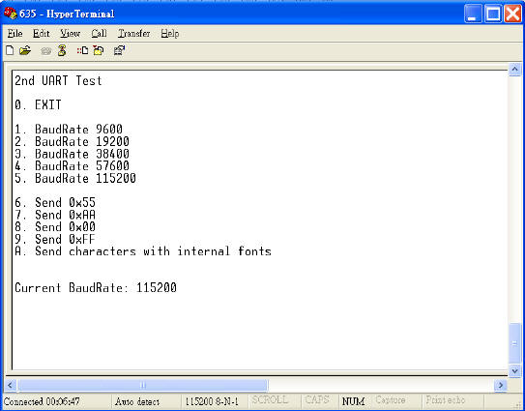

**EEPROM Test**

This screen lets you test the EEPROM’s functionality

Address

Writing values

LO/HI page

Previous memory page

Back to main screen

Next

memory page

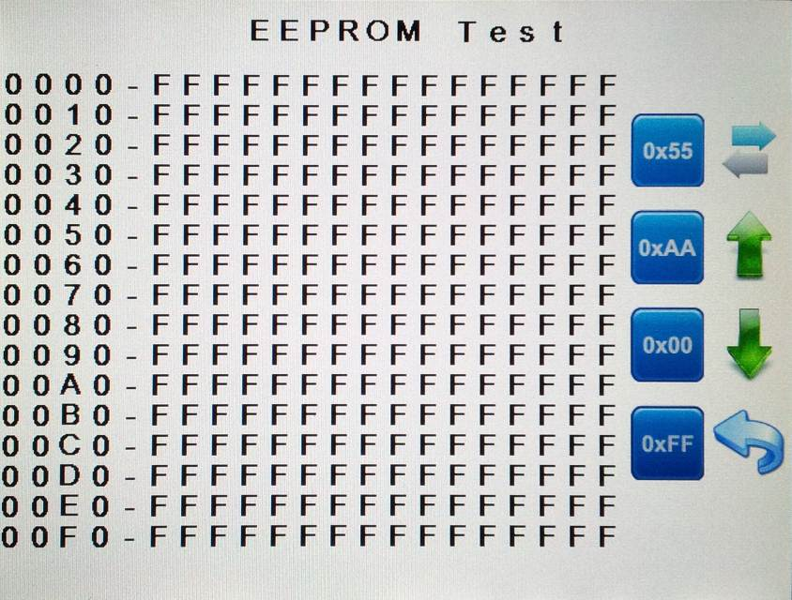

**Step 1:** Select a memory page you would like to see by using the  buttons.

**Step 2:** With the LO/HI page button , address are switched to current address + 8 and back.

**Step 3:** Select a value (0x55, 0xAA, 0x 00, 0xFF) with which you would like to fill the current memory page (fills low and high page).

**Step 4:** In Terminal mode, the screen shows as depicted below, on your keyboard, please hit the respective number to execute the operation.

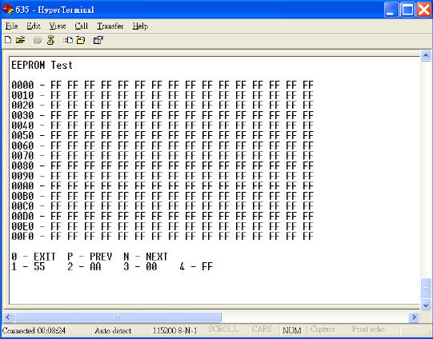

### I2C Test

This screen lets you test the I2C EEPROM’s functionality[1]. Please make sure the test board is connected to BE635 and 5V power supply is connected to the test board.

Address

Writing values

LO/HI page

Back to main screen

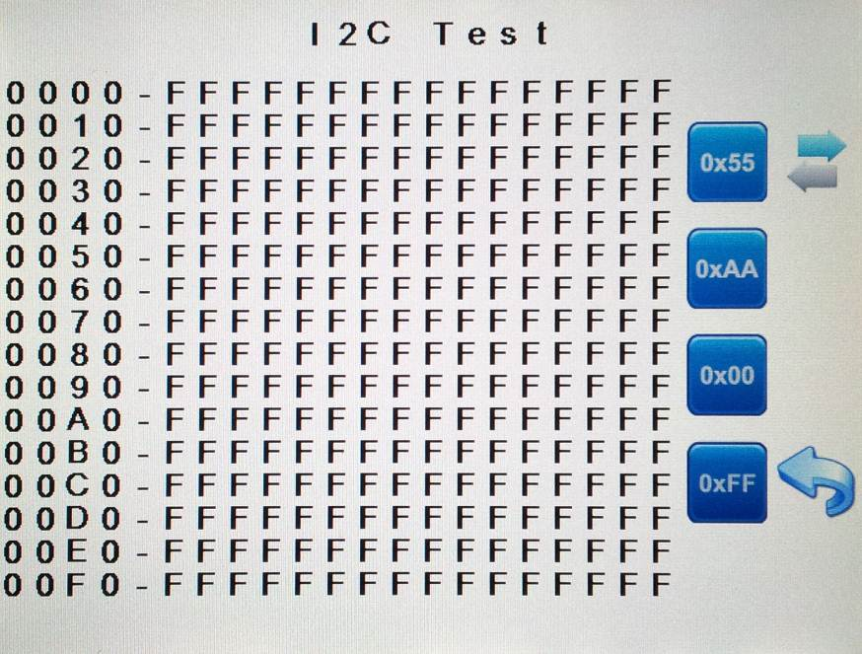

**Step 1:** Select a value with which you would like to fill the current memory high and low memory page: 0x55, 0xAA, 0x 00 or 0xFF.

**Step 2:** With the LO/HI page button , address are switched to current address + 8 and back.

**Step 3:** In Terminal mode, the screen shows as depicted below, on your keyboard, please hit the respective number to execute the operation.

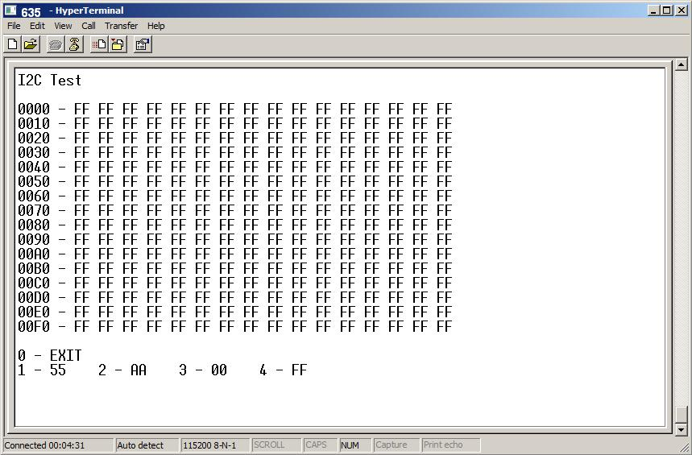

### SPI Test

This screen lets you test the SPI FLASH’s functionality[2]. Please make sure the test board is connected to BE635 and a 5V power supply is connected to the test board.

Address

Writing values

LO/HI page

Back to main screen

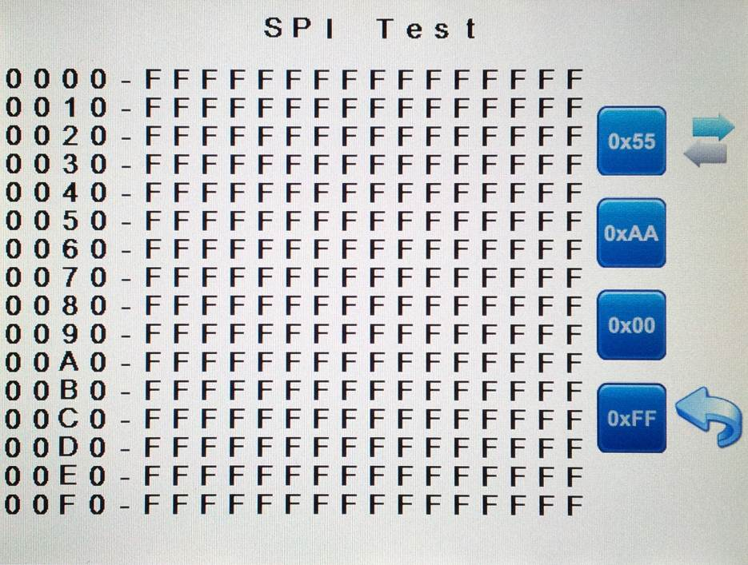

**Step 1:** Select a value with which you would like to fill the current memory high and low memory page: 0x55, 0xAA, 0x00 or 0xFF.

**Step 2:** With the LO/HI page button , address are switched to current address + 8 and back.

**Step 3:** In Terminal mode, the screen shows as depicted below, on your keyboard, please hit the respective number to execute the operation.

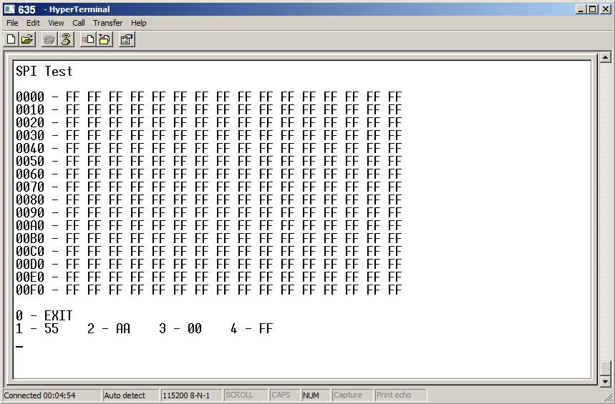

### ADC Test

This screen lets you test the ADC’s functionality. Please make sure the test board is connected to BE635 and a 5V power supply is connected to the test board.

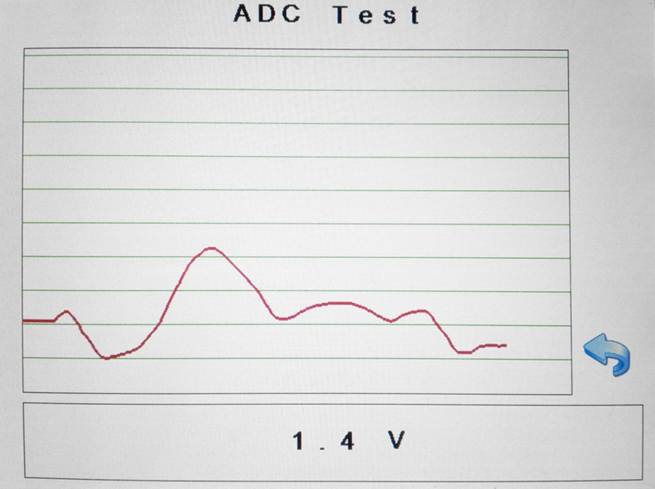

Current ADC value

ADC values vs. time

Back to main screen

**Step 1:** Vary the potentiometer on the test board and observe the values being drawn on the screen.

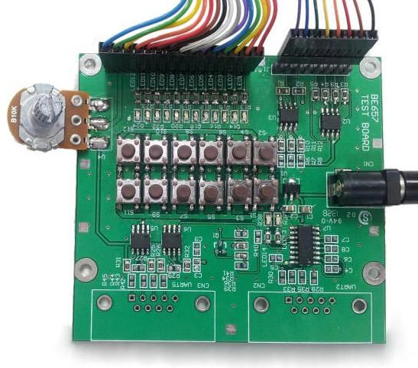

**Step 2:** In Terminal mode, the screen shows as depicted below, on your keyboard, please hit 0 to exit the test.

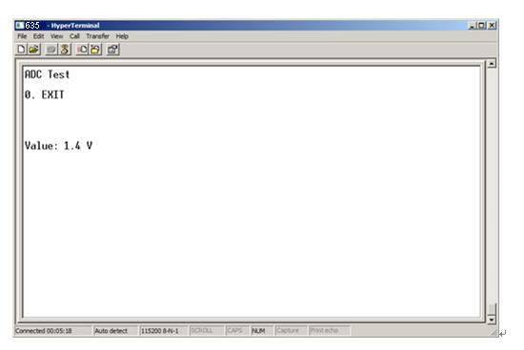

**GPIO Test**

This screen lets you test the general purpose I/O functionality, please make sure the test board is connected to BE635 and a 5V power supply is connected to the test board.

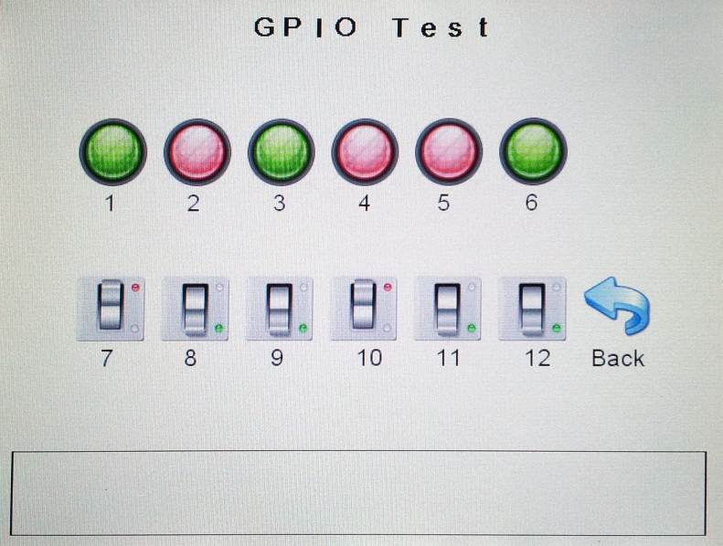

Status of **input** pins

Input High : Green

Input Low : Red

Status of **output** pins

Output High: Green

Output Low : Red

Back to main screen

**Step 1:** The GUI lets you see the state of the GPIO pins. In the demo test program, GPIO_1 ~ GPIO_6 are set as input pins and GPIO_7 ~ GPIO_12 are output pins. Whenever the value of the input pins change, the value of related output pins will change accordingly. Here is the mapping table of demo test program. You can change the I/O mode of each pin in your program. Detailed information about GPIO control can be found in **section 2.8 of the programming guide**.

|  |  |  |  |  |  |  |
| --- | --- | --- | --- | --- | --- | --- |
| **Input pin** | GPIO_1 | GPIO_2 | GPIO_3 | GPIO_4 | GPIO_5 | GPIO_6 |
| **Output pin** | GPIO_7 | GPIO_8 | GPIO_9 | GPIO_10 | GPIO_11 | GPIO_12 |

For above setting of the output pins (8, 9, 11, 12 high level), the results can be seen in the image below.

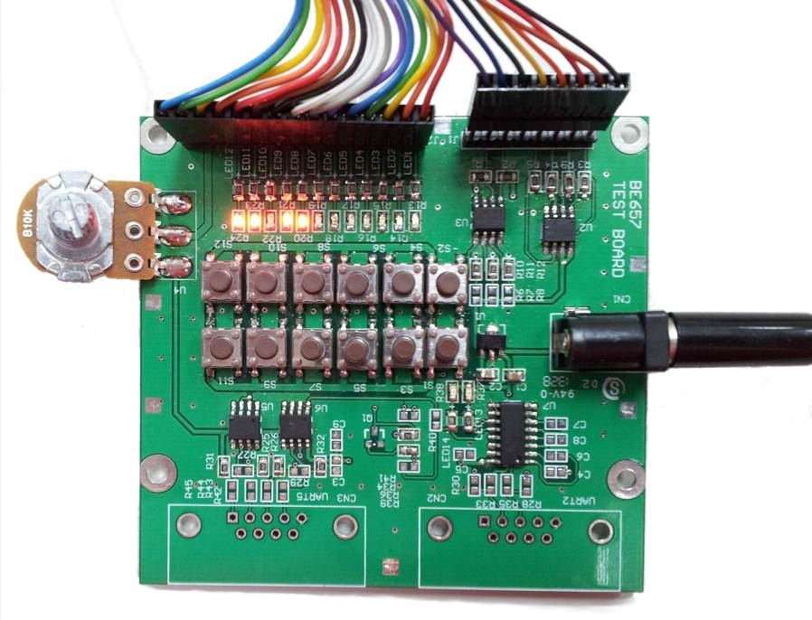

**Step 2:** In Terminal mode, this screen shows as depicted below. On your keyboard, please hit 1-6 to toggle the state of the output pins. In the **MODE** line, the mode of the GPIO pins are shown with GPIO pin 1 on the left and pin12 on the right (**I**=Input, **O**=Output). The **VALUE** line displays the state of the pin. Press 0 to return to the main screen.

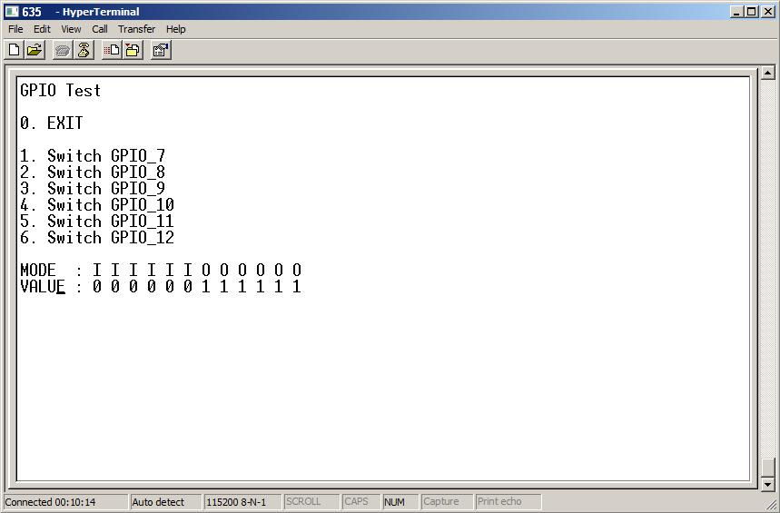

**SD Card Test**

This screen lets you test the SD Card’s read/write/delete functionality.

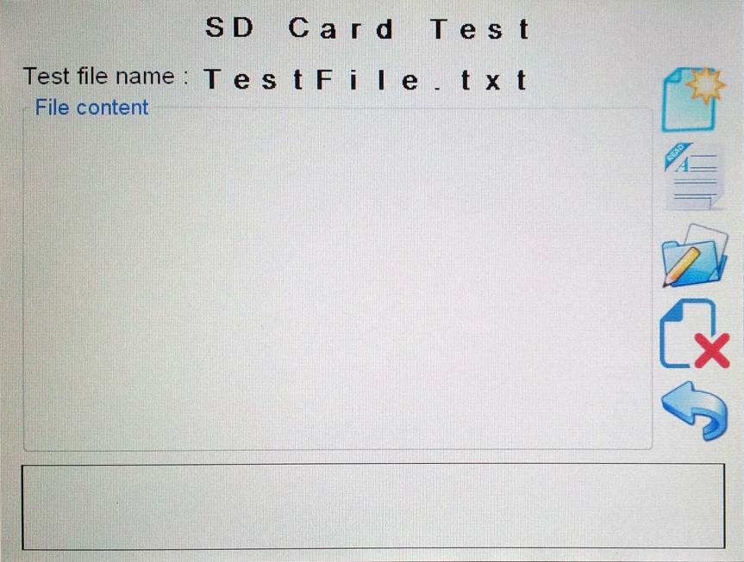

Back to main screen

Delete file

Write to file

Read file

Create new file

File contents

**Step 1:** From the operations on the right hand side, choose “**Create**”, “**Read**”, “**Write**” or “**Delete**”. The contents of the file on the device are shown in the contents area.

|  |  |
| --- | --- |
| **ICON** | **Description** |
| 圖片 11 | Create new txt file on SD card |
| 圖片12 | Read txt file contents of SD card and display on BE635 |
| 圖片 12 | Write the string to txt file on SD card |
| 圖片 13 | Delete the txt file of SD Card |

**Step 2:** The different operations performed on the device will show the results as depicted in below images.

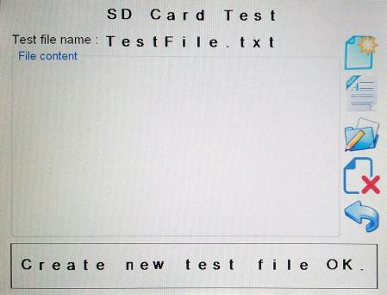 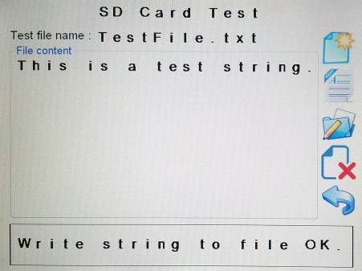 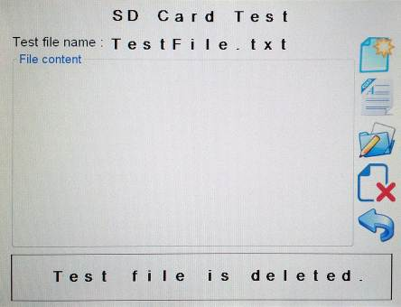

Delete

Create

Write

**Step 3:** In Terminal mode, the screen shows as depicted below.

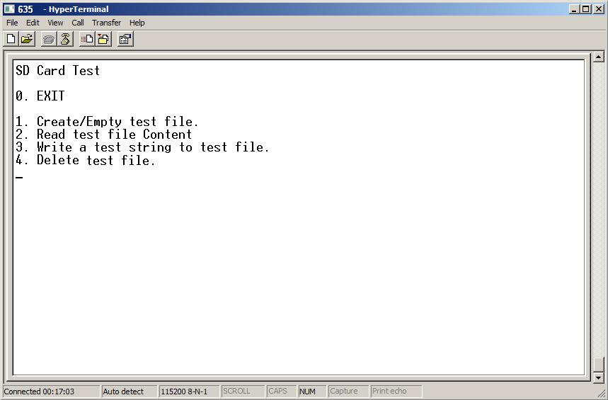

**Step 4:** On your keyboard, please hit the respective number to execute the operation.

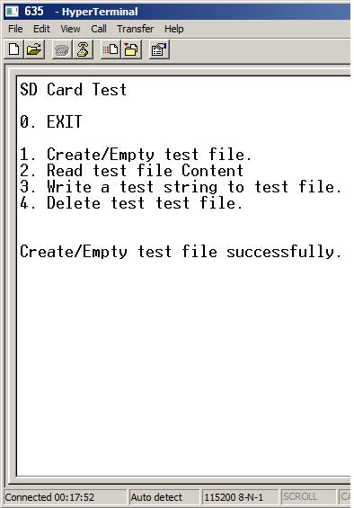 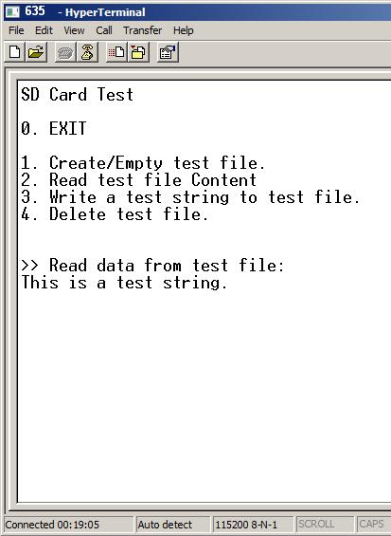 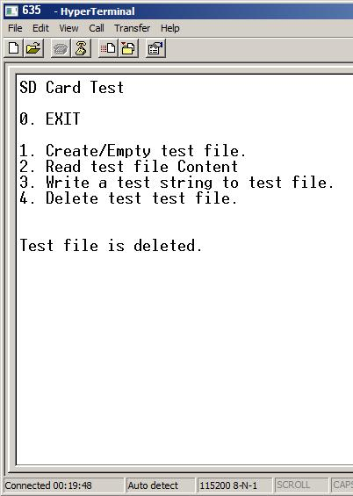

Delete

Read

Create

### Buzzer Test

This screen lets you test the Buzzer functionality.

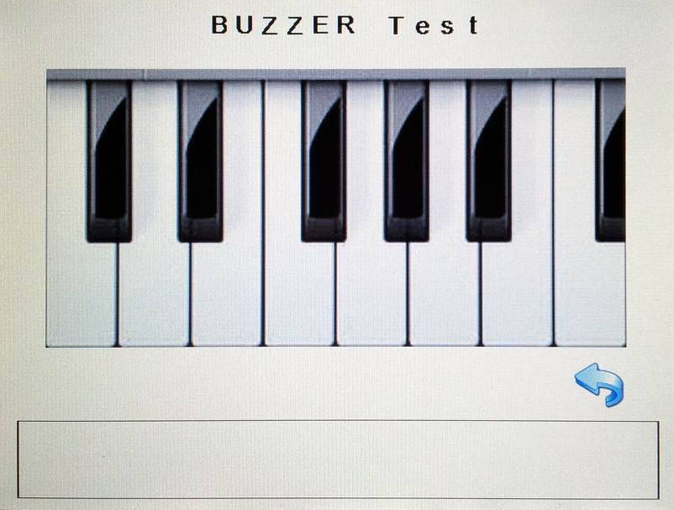

Back to main screen

**Step 1:** Hit the black or white keys on the piano. The respective note will be played through the buzzer.

**Step 2:** In Terminal mode, the screen shows as depicted below, on your keyboard, please hit the respective number to play a certain tone. Press 0 to return to the main screen.

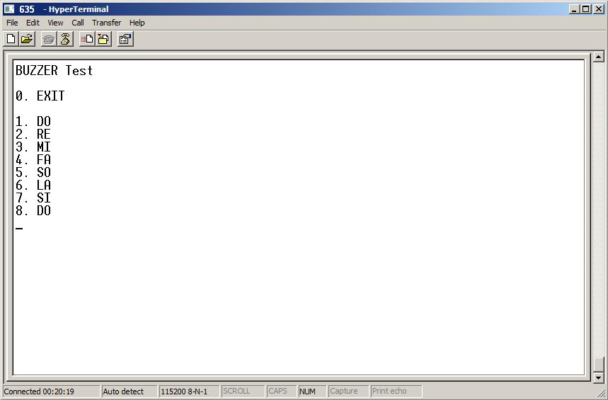

### Touch panel Draw Test

This screen lets you test the touchpad functionality using a simple drawing program.



Back to main screen

**Step 1:** Write text or hit certain coordinates and check in the terminal window, if the coordinates is not match the coordinates of the touched point. A calibration might be necessary before using the drawing program.

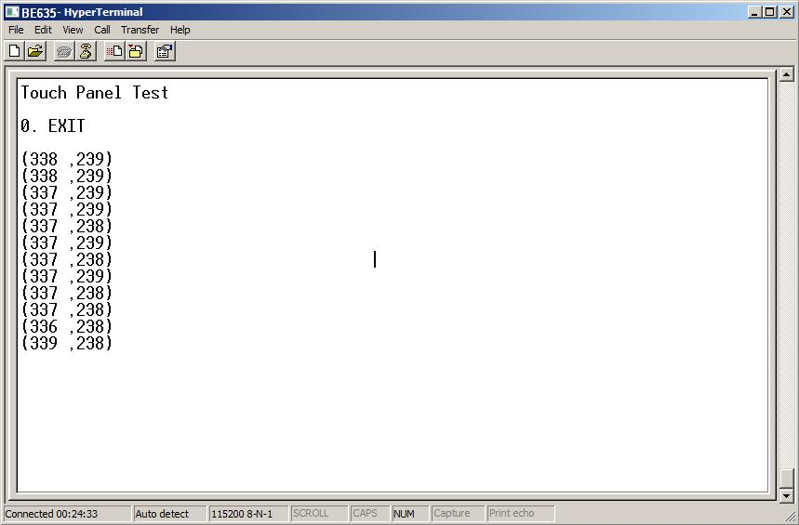

### LCD Test

This screen lets you test the image and built in font functionalities.

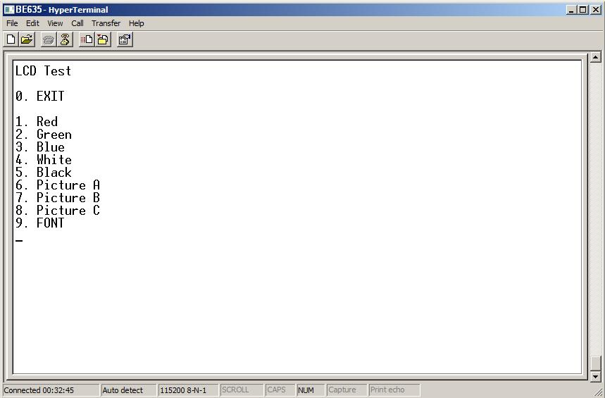 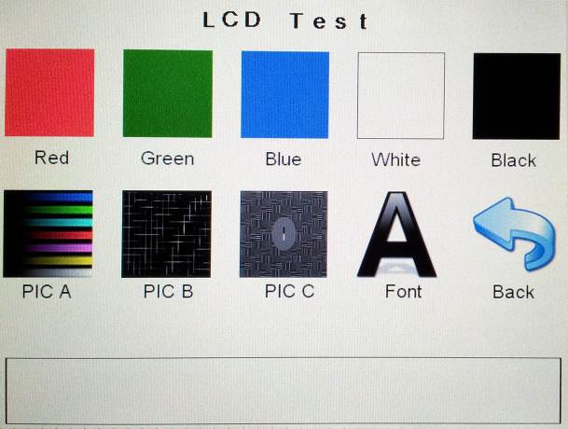

(Hyper Terminal Screen) (BE635 Screen)

**Step 1:** Operations that can be performed are filling the screen with red, green, blue, white, and black as well as showing images and fonts.

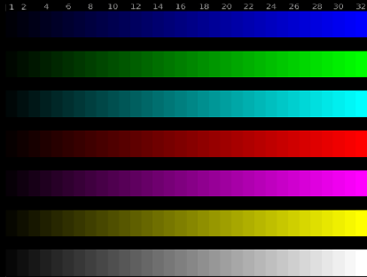 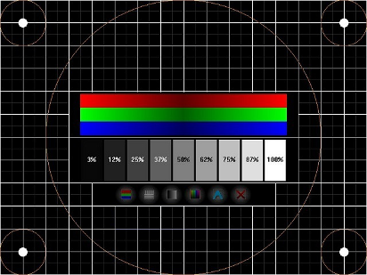 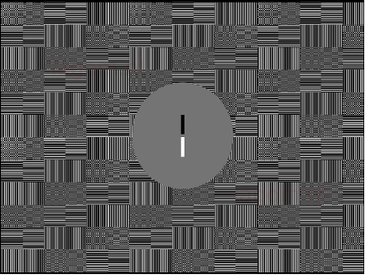

Picture C

Picture A

Picture B

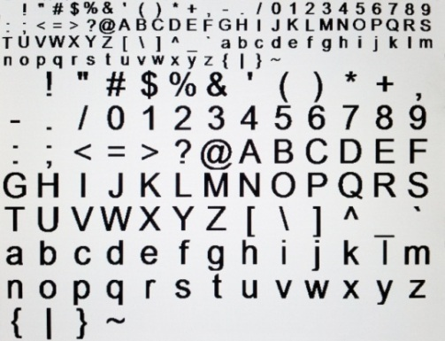

Font

### System Setting

This screen lets you set the system’s backlight intensity, display the product information and calibrate the touch panel.

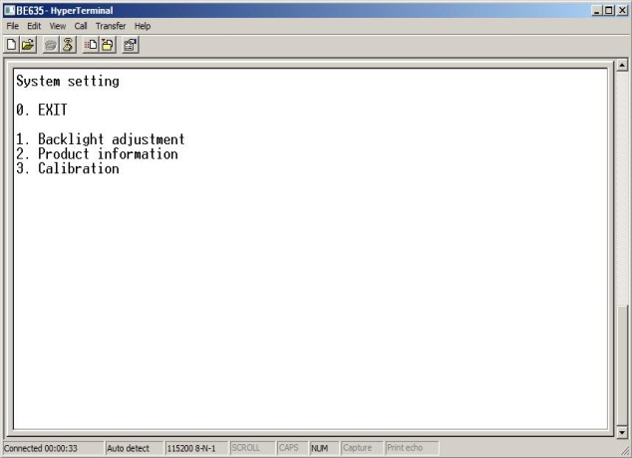 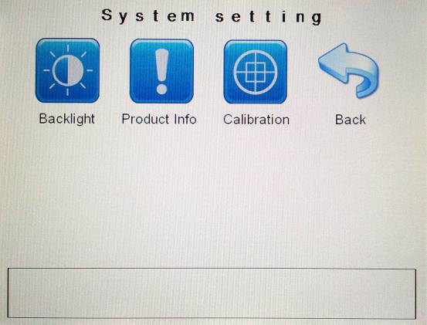

(Hyper Terminal Screen) (BE635 Screen)

|  |  |
| --- | --- |
| **ICON** | **Description** |
| 圖片 4 | The backlight can be adjusted from 10% to 100% in steps. |
| 圖片 2 | The product information displays the product information stored in memory. |
| 圖片 3 | Calibration is performed by using 5-points calibration where each of the 5 points is being touched successively. |

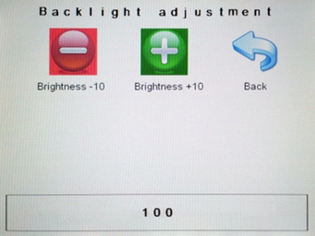 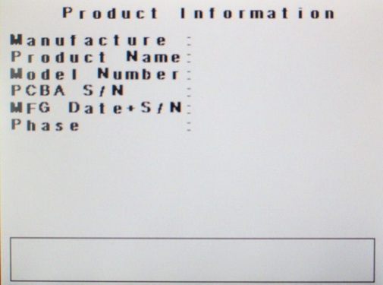 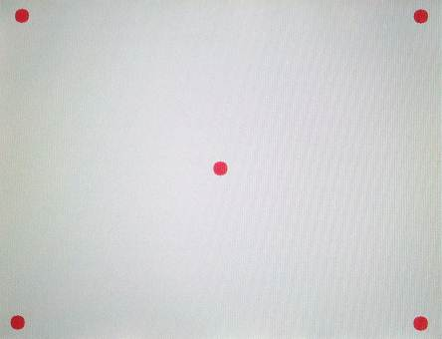

Calibration

Product info.

Backlight

In terminal mode, the screens show as depicted below.

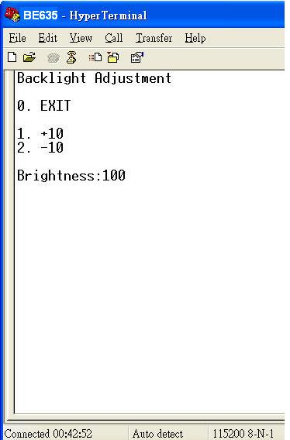 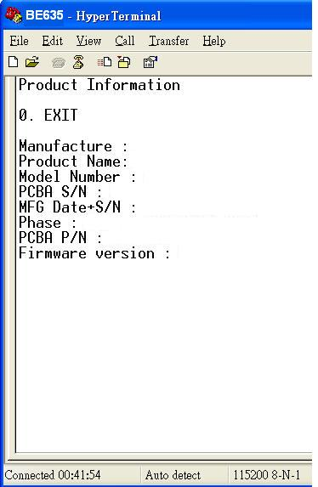 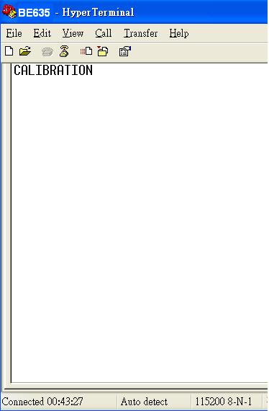

Calibration

Product info.

Backlight

**< End of BE635 User Manual >**

1. The I2C EEPROM is an application example by Bolymin. Any kind of I2C device can be connected to BE635
2. The SPI FLASH is an application example by Bolymin. Any kind of SPI device can be connected to BE635